**IDEAS: Request for Information (SS-RFI)/ Draft Statement of Objectives (SOO)**

RFI Number: 70SBUR19I00000038

Posted Date: 7/18/2019

Response Date: 8/1/2019

NAICS Code: 541511, 541512

**Submitted to:**

Contracting Officer

Emilio Cibula, Contract Specialist

Emilio.A.Cibula@uscis.dhs.gov

**Submitted by:**



Chris Arbore

Technalink, Inc.

7900 Tysons One Place, Suite 610

Mclean, VA, 22102

703.203.7500

www.technalink.net

Table of Contents

**1.** **Introduction** 2

**2.** **Augmented Analytics Platform for Feature Engineering & Process Intelligence** 2

# **Introduction**

Driven by on Team TechnaLinkʼs core competencies in process improvement, automation and augmented analytics backed by AI and ML, we have outlined product and platform enhancement ideas inspired by various aspects within the scope of the first and the third technical areas, namely:

* **Technical Area 1** - Automation-first approach to assist in the advancement of services and technologies using AI/ML for operations and site reliability.
* **Technical Area 3 -** fault-tolerant data connectors across disparate sources and interfaces with learning and adaptive functions.

# **Augmented Analytics Platform for Feature Engineering & Process Intelligence**

**dataGrind®** is a home-grown product offered as a COTS solution, once installed and configured can be used directly to connect to various data sources/databases for analysis using custom ad-hoc reporting and dashboards.

Simple licensing model – Perpetual or Subscription for Managed Service, Cloud, On-Prem implementation that costs less than half of most BI tools in the market. No desktop components required, access from any device anywhere.

Figure 1: Augmented Analytics Platform

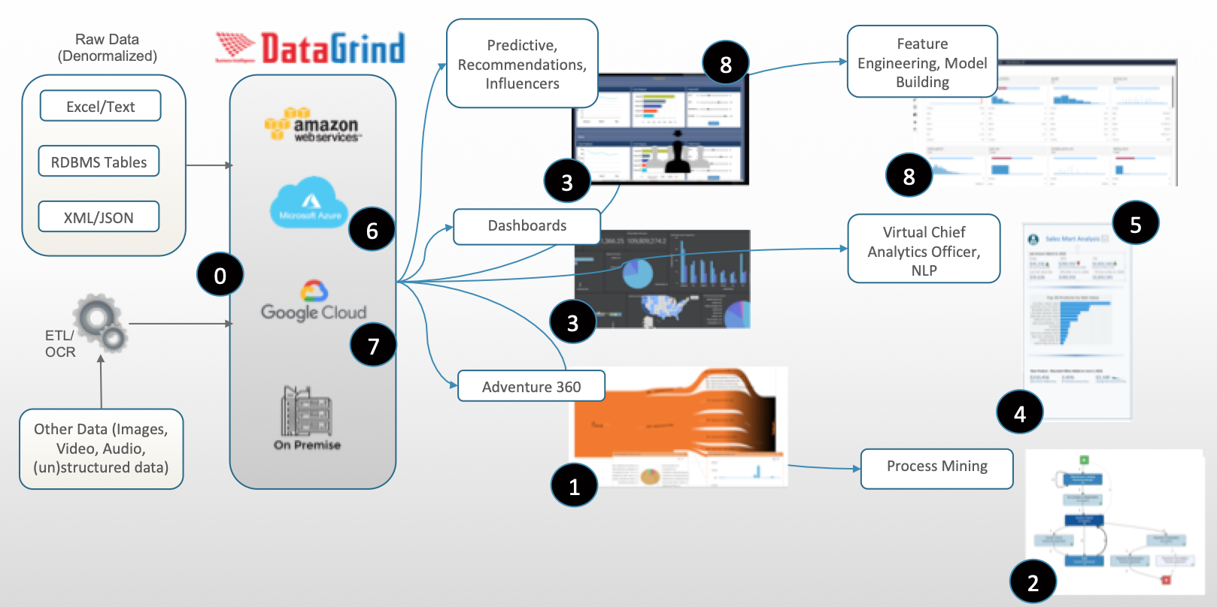

**Features highlights:**

**0. Data Connectors:** Our framework refined over time bridges the data sources gaps. For instance, data originating from mainframe targeted for data lake built on HDFS, our framework provides support for EBCDIC data, complex Cobol copybooks and mainframe record formats like VSAM, fixed, variable, packed decimal.

**1. Adventure 360:** All your analytics in a single interface. Start with any metric and analyze all the way to lowest level of your data dimension within seconds with simple clicks. Compare apples to apples or apples to oranges to quickly identify business insights

**2. Process Mining/Intelligence:** Create, automate and analyze process mining with simple selections of dimensions

**3. Dynamic KPI:** Create a KPI on the fly and let it persist when you add or remove columns and rows (this can be applied for reports)

**4. Virtual CAO:** Virtual Chief Analytics Officer functionality provides automated trends and key metrics

**5. NLP:** Google search type query to get your answer(s) in seconds on all your data

**6. Dynamic Cube:** From raw data to dashboards and insights in seconds (this can be applied to dashboards and or reports)

**7. Dynamic Security:** Built in feature to support data level security for any user by any metric and dimension

**8. AI Support & data support for Feature Engineering:** Use built in Predictive Models or create your own using our Predactica interface. NLP and Neural networks-based scores for NPS, Customer Satisfaction, Emotion and Sentiment